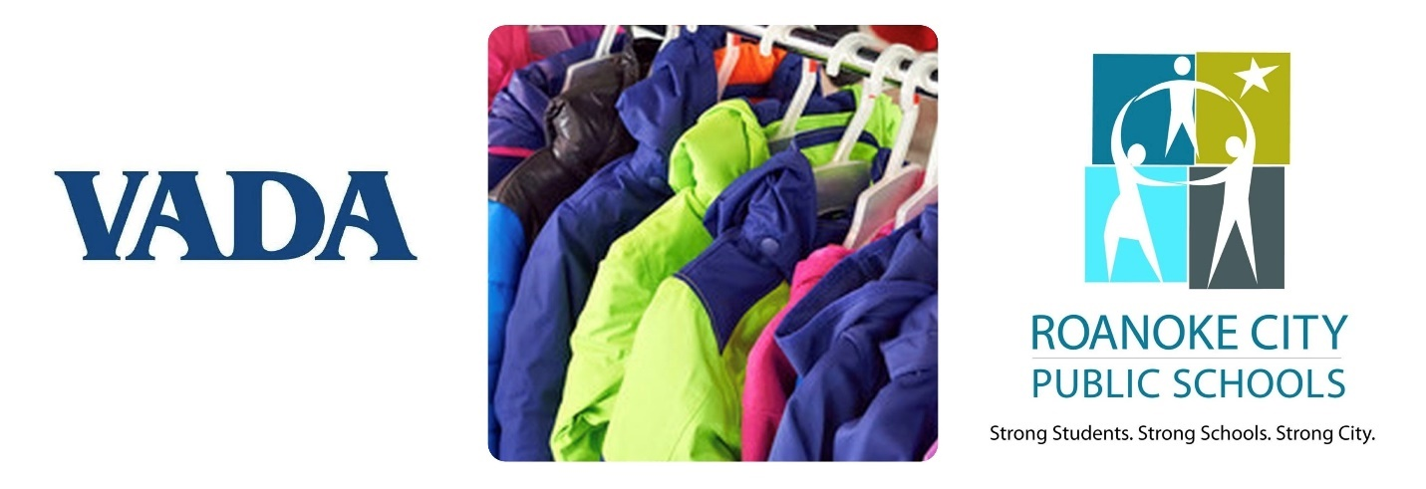
Share the Warmth!
VADA Winter Coat Drive

With the autumn and winter chill just a few months away, many students lack the clothing they need to stay warm this cold weather season. In addition to its effect on overall wellness, this lack of appropriate winter gear can have a detrimental effect on students’ self-confidence, attendance, and performance.

In conjunction with our 2022 Annual Meeting at the Hotel Roanoke and Conference Center this October 12-14, the Virginia Association of Defense Attorneys invites you to help share the warmth for students in need with our 2022 Winter Coat Drive! From now until October 14, we are collecting new and gently used winter coats, children through teen. Cash donations, too, are both welcome and appreciated! All coats and funds collected benefit the students of Roanoke City Public Schools.

We will collect all coats and cash donations at our Annual Meeting. If you will not be making the trip to Roanoke, or if you would rather deliver your donation ahead of time, please contact our Executive Director, Sherma Mather, at (804) 649-1002 or smather@vada.org. Monetary donations may be made by cash or check. Please make all checks payable to “Roanoke City Public Schools” and include “VADA Winter Coat Drive” on the memo line.

On behalf of the Virginia Association of Defense Attorneys, we thank you for your generosity and your support!

