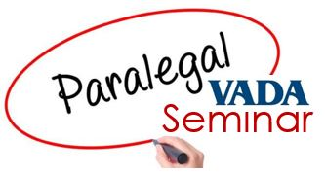
Via Zoom
August 23, 2023
Agenda

10:00-10:45 Tips and Best Practices for Assisting with Document Review & Production
This session will share tips and best practices for collecting, organizing, reviewing and producing documents from parties as well as non-parties for cases (and firms) of all sizes, including privileges to be aware of when reviewing documents to be withheld, Virginia spoliation laws, and federal production/preservation issues. Also includes a discussion of the privileges to be aware of when reviewing documents to be withheld, Virginia spoliation laws, and federal production/preservation issues topics.

Lindsay Rollins, Attorney, The Progressive Group

10:45-11:45 The Rules of Engagement: Primer on Federal and State Court Rules
This session will address topics such as where to find applicable rules, most used rules, recent changes to rules, and how to find local rules and customs.

James Cales, Attorney, Furniss Davis Rashkind & Saunders

11:45-12:45 Lunch/Work Break

12:45-1:45 Trials 101: A Paralegal’s Role in Trial Prep and Trial
This session will address how to work up a case before trial, what’s needed as you approach trial, local rules and procedures to watch out for, use of demonstratives, and the paralegal’s role as air traffic controller during trial and include a discussion of what needs to be in your Trial Toolkit.

Taylor Brewer, Attorney, Moran Reeves Conn
Brandon Menzie, Paralegal, Moran Reeves Conn

1:45-2:45 Who’s Who? How to Effectively and Efficiently Research Jurors
Where and how do you ethically look for juror information, what information is relevant and important, and what are the best formats for organizing juror information for the trial attorney?

Jonathan Hyslop, Attorney, Furniss Davis Rashkind & Saunders

